Table of Contents

2 How to configure the blueprint to install Grafana into the Karbon Kubernetes Cluster 2

2.1 Product Configuration: 2

2.2 Objective of this blueprint 2

2.3 Configuration Steps: 2

2.4 Download latest Karbon Kubeconfig 10

2.5 Un-install Grafana 11

2.6 Install Grafana 11

2.7 Delete the application 11

# How to configure the blueprint to install Grafana into the Karbon Kubernetes Cluster

## Product Configuration:

* Calm 3.2.0
* Karbon 2.2.1

## Objective of this blueprint

The objective of this blueprint is to install Grafana into the Karbon Kubernetes cluster.

## Configuration Steps:

1. Upload the blueprint Grafana.json (Ubuntu) or Grafana-centos.json into Calm.
2. Change the Credentials

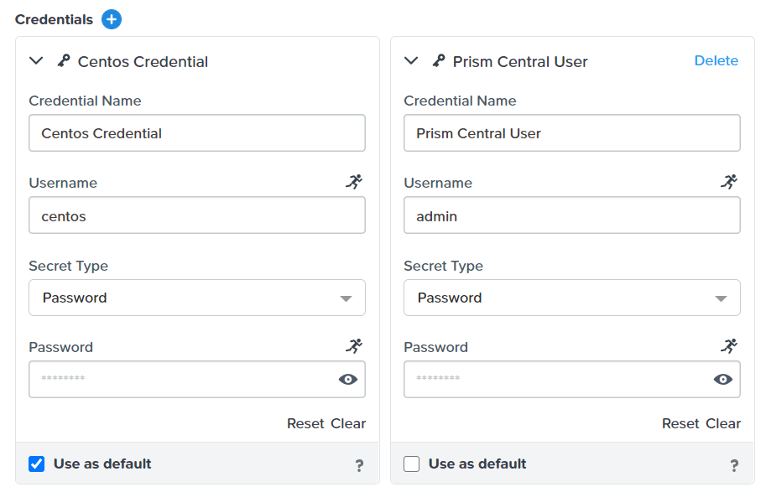

1. Click on the VM. Change the image to Centos. The Centos image must be configured not to prompt for password for sudo.

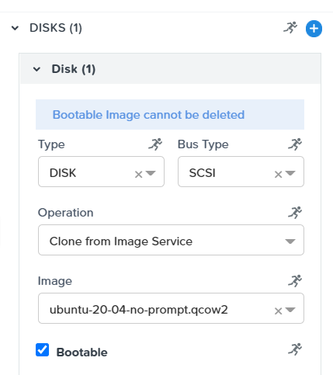

1. Scroll down to configure the NIC1

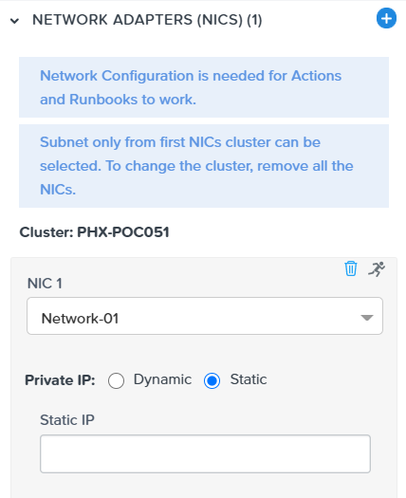

1. Click on the Application Profile->Default.

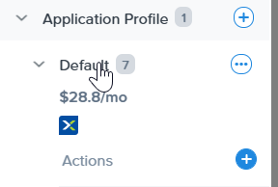

1. Change this variable to suit your local environment.

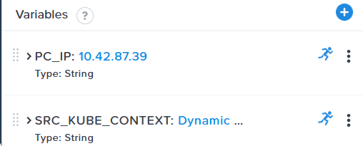

1. **PC_IP** – Configure the IP address of the Prism Central
2. **Drill into the SRC_KUBE_CONTEXT to change the credential in the pc_user and pc_password variable** – A bug in the credential macro would be fixed in Calm 3.3.
3. Launch the application

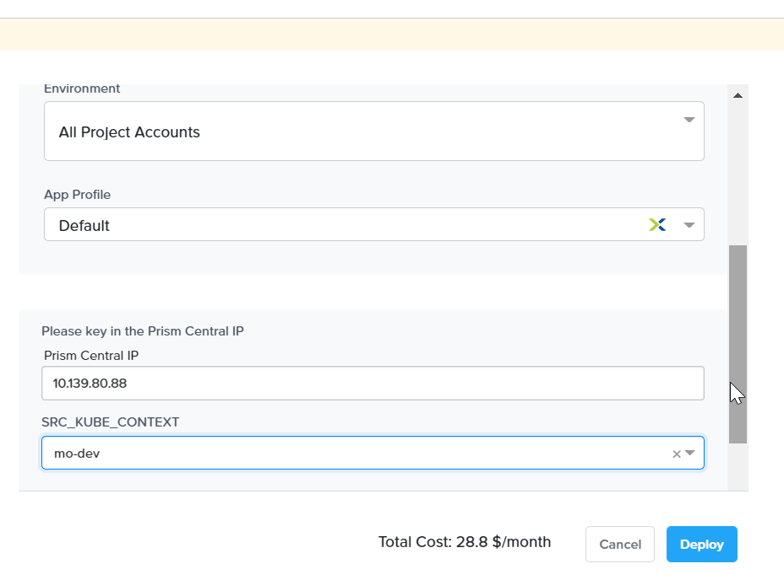

1. Wait for the application launch to complete. Drill into the application. Click on Services. Click on the Nutanix on the left side. Note down the IP address

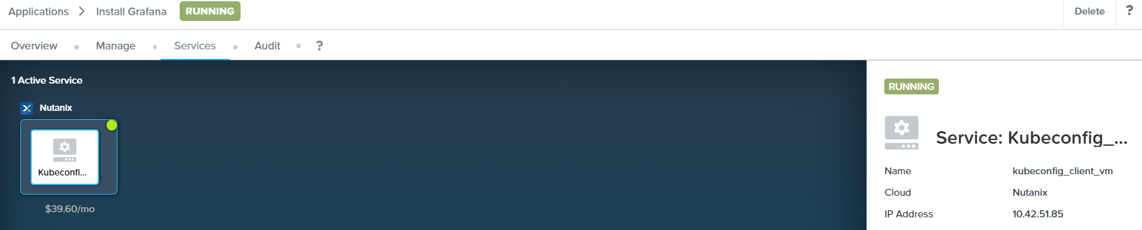

1. Putty into the IP address. Run this command.

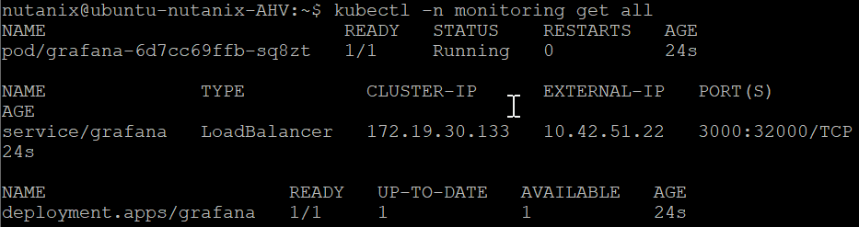

1. Open the browser and key in <http://10.42.51.22:3000>. Key in
   1. Username: admin
   2. Password: admin

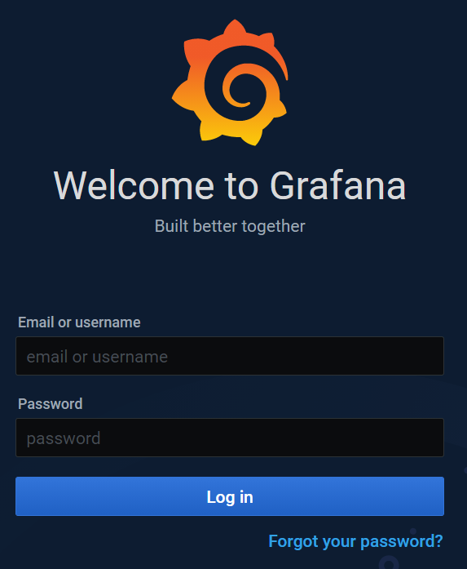

1. Press skip

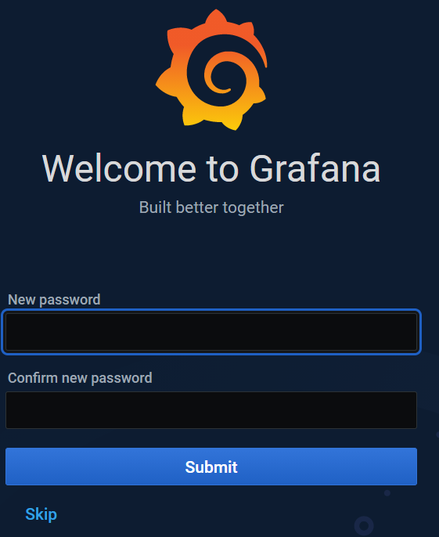

1. This is the home page for Grafana

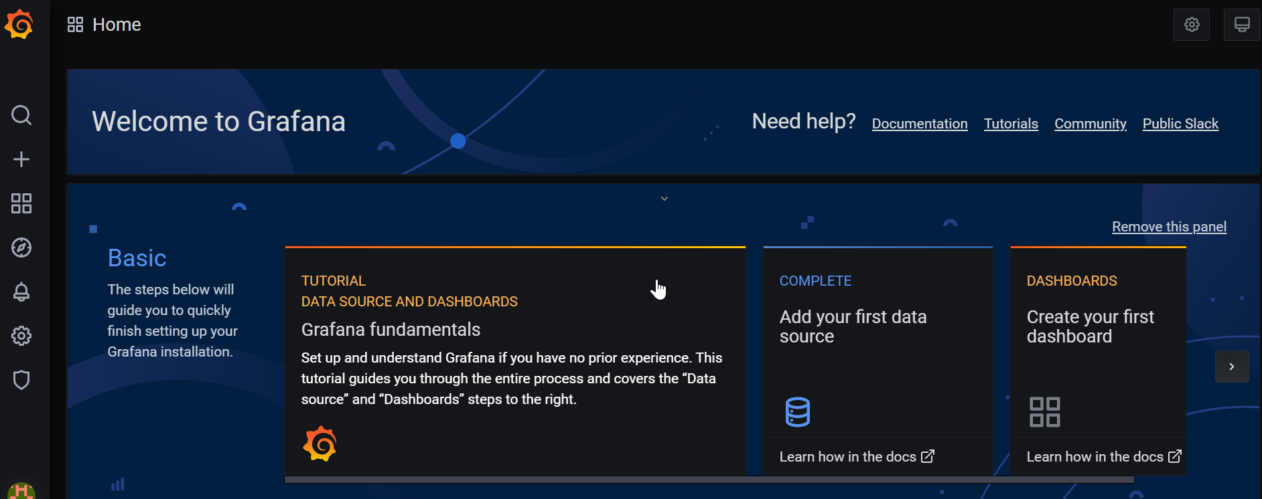

1. Click on “Add your first data source” to add the connection to the Prometheus

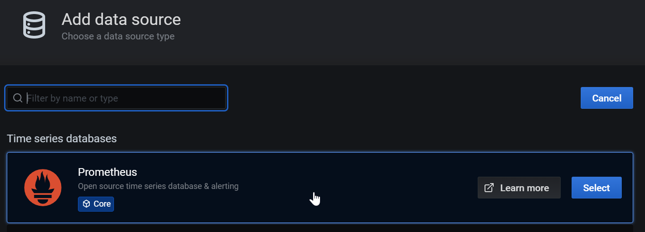

1. Fill in the following url:

[http://prometheus-k8s.ntnx-system.svc.cluster.local:9090](http://prometheus-k8s.ntnx-system.svc.cluster.local:9090/)

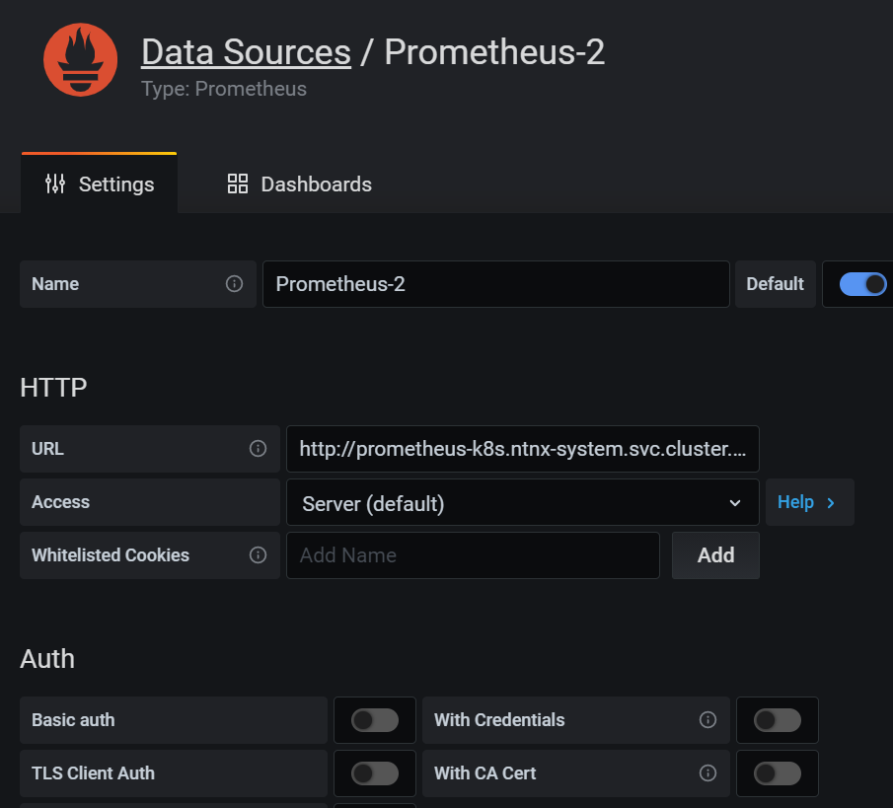

1. Click on the + to import a new dashboard

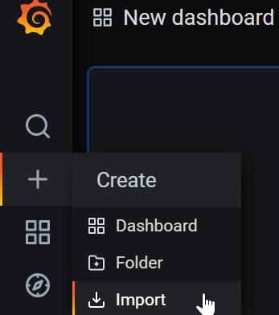

1. Key in 5315. Click on Load. Repeat for 5309, 5312, 5315, 5303, 5324, 5318, 5321

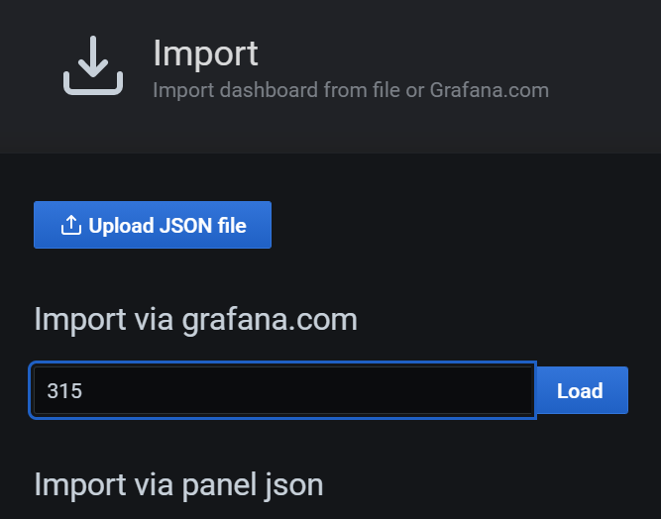

1. Click on Import

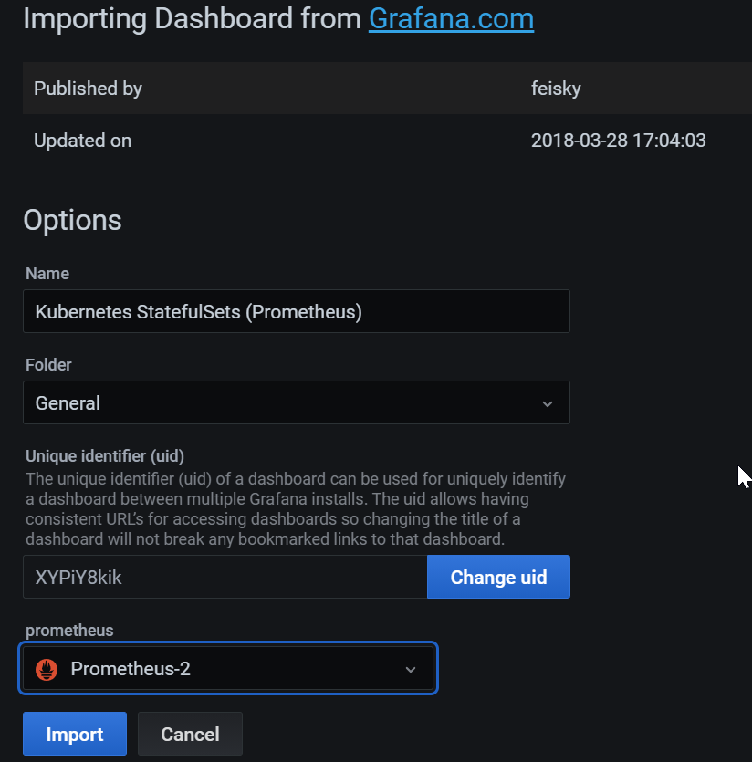

## Download latest Karbon Kubeconfig

Karbon Kubeconfig has a lifespan of 24 hours. Run this step in Calm application to download the latest Kubeconfig

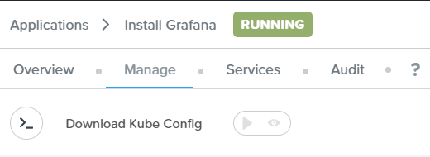

Wait a min for the step to complete execution.

## Un-install Grafana

If you would like to un-install Grafana from the Karbon Kubernetes cluster, run this command.



## Install Grafana

If you would like to install Grafana into the Karbon Kubernetes cluster, run this command



## Delete the application

If you did not want to un-install Grafana from the Karbon Kubernetes cluster and would like to reclaim back the VM, you could run the delete command to delete the application